UNCLE DAVE’S

HOUSING FOR MEN

**CALL TODAY!!!**

**(424) 652-1191**

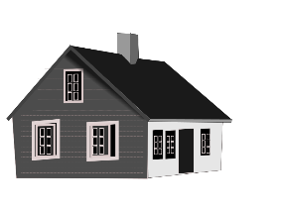 **$550 - $600 A MONTH** 

**SHARED HOUSING FOR MEN**

MONTHLY RENT INCLUDES EVERYTHING

(ALL UTILITIES, CABLE TV & WIFI)

NO SECURITY DEPOSIT – NO CREDIT CHECK

**THE CLEANEST & SAFEST HOUSING**

**FOR MEN IN LOS ANGELES**

 **GR ACCEPTED** 

**WITH HOUSING APPLICATION**

**SEE ALL SIX SOUTH LOS ANGELES LOCATIONS AT:**

[**WWW.UNCLEDAVESHOUSING.ORG**](http://WWW.UNCLEDAVESHOUSING.COM )